1. Contact Page title issue – Contact_info => Contact Info
2. Location show korena

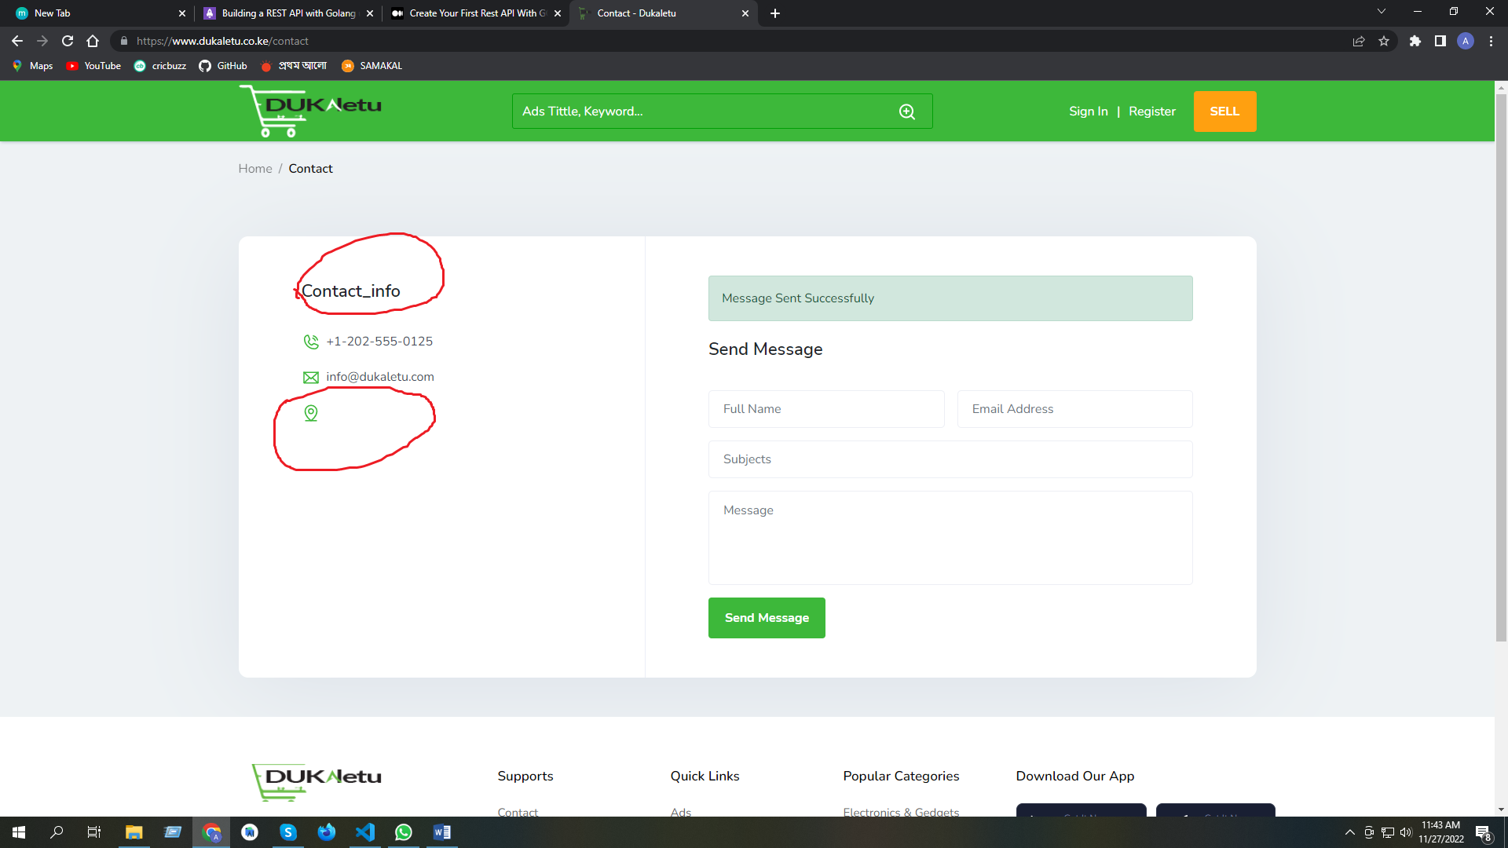

1. Sell add korci Response Internal server erro. 2 times try korci 2 times e Response Internal server. 3rd time 1st step e ase next button press korci warning title alreay exist. Then dashboar e check kori sell create hoice.

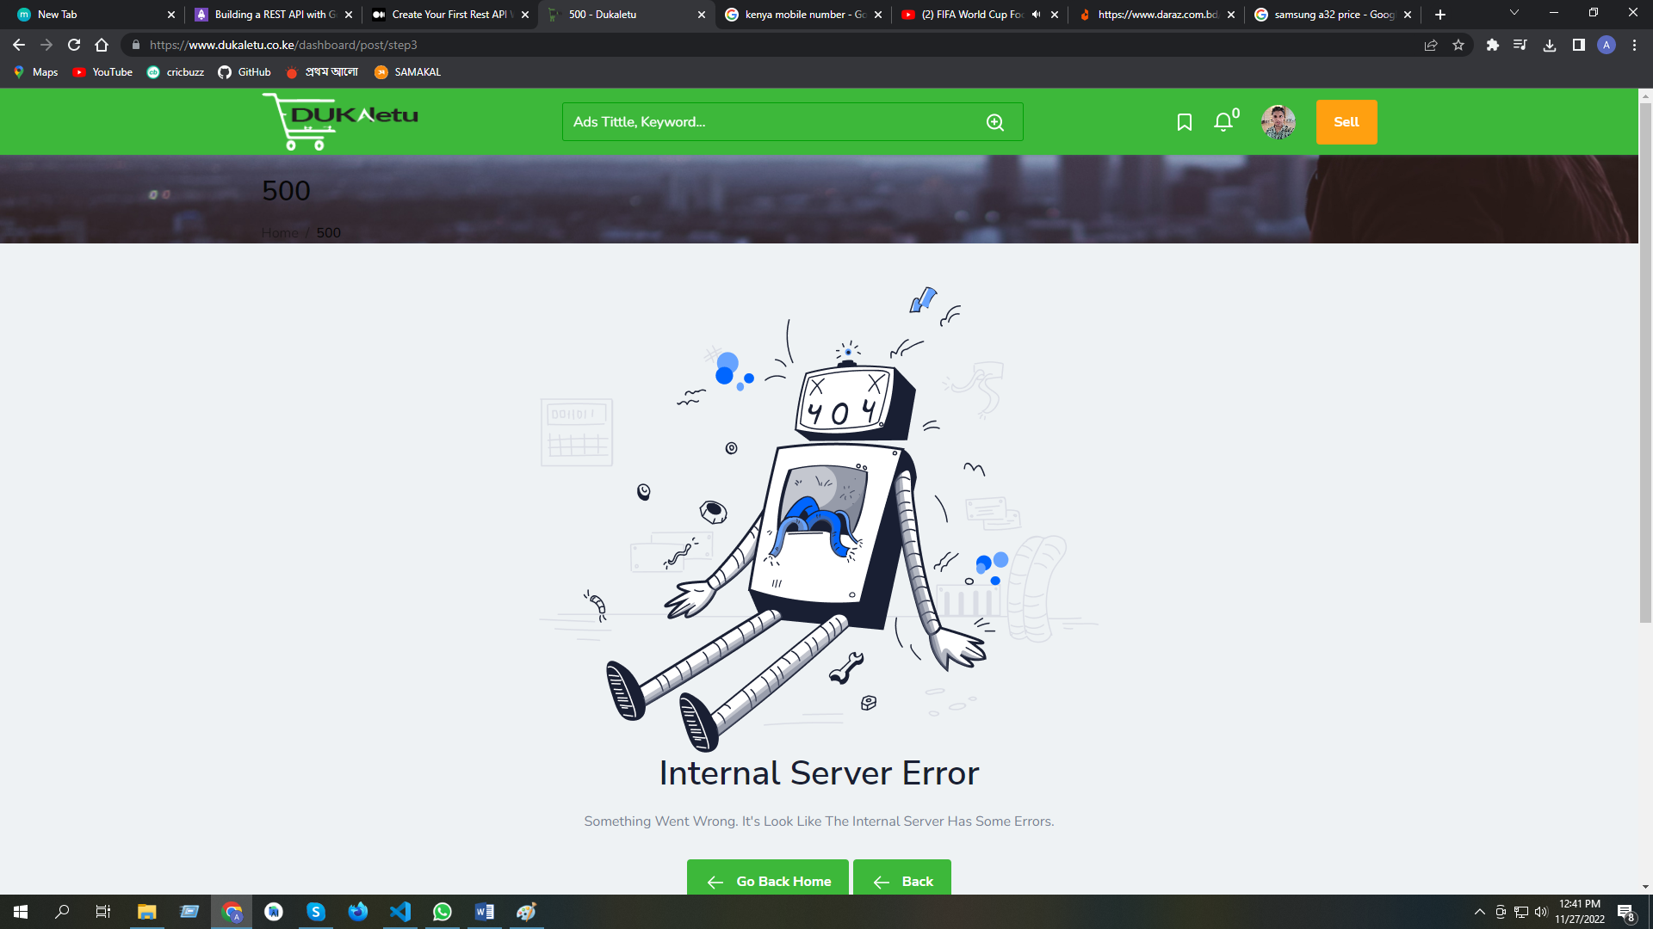

1. Dashboard e product price $ dollar sing e show hoy.

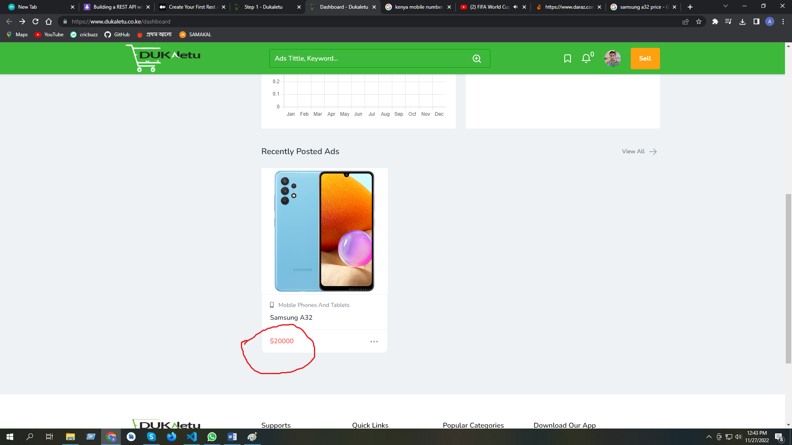

1. Product Sell entry dilam 2 picture but add holo 3 ta. Last picture ta double hoye gece
2. Location show hoyna.

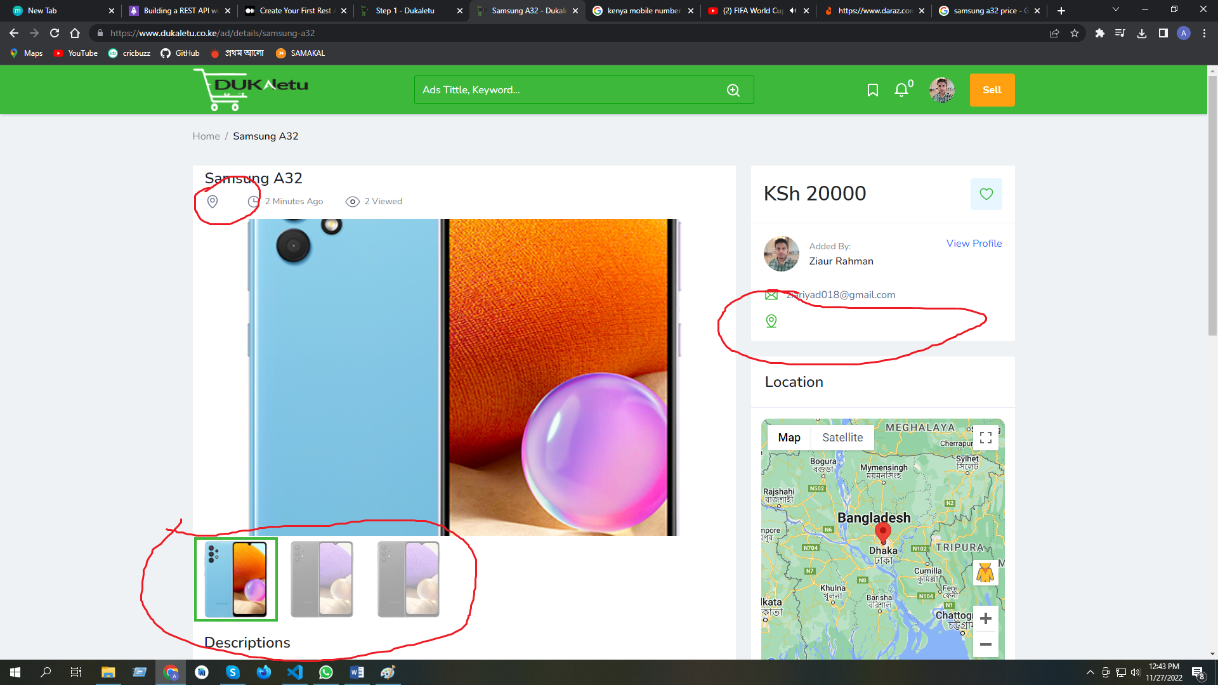

1. Product sell entry deyar ageo Remaining Ads 3 and After also Remaining Ads 3\
2. Registration er somoy username “riyad” dilam ar akhane show kortece arekta
3. akhane last image 3 bar override hoice.
4. matro publish korci time show hocce 33 minutes ago

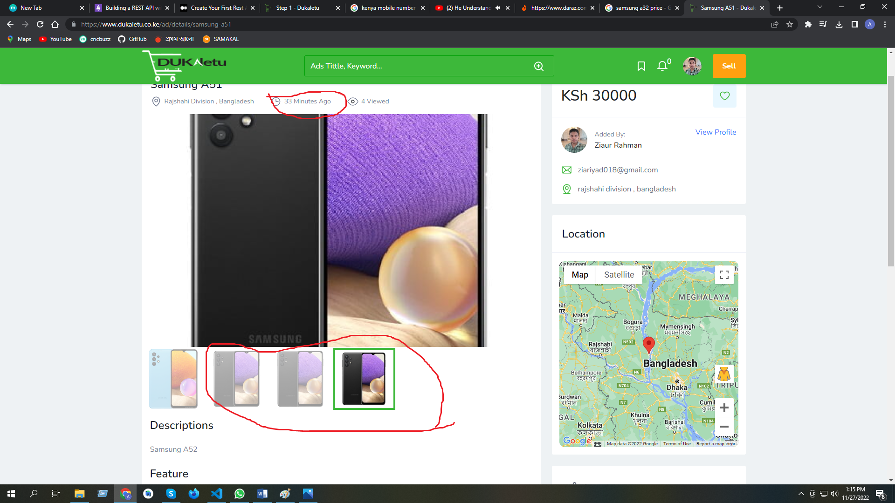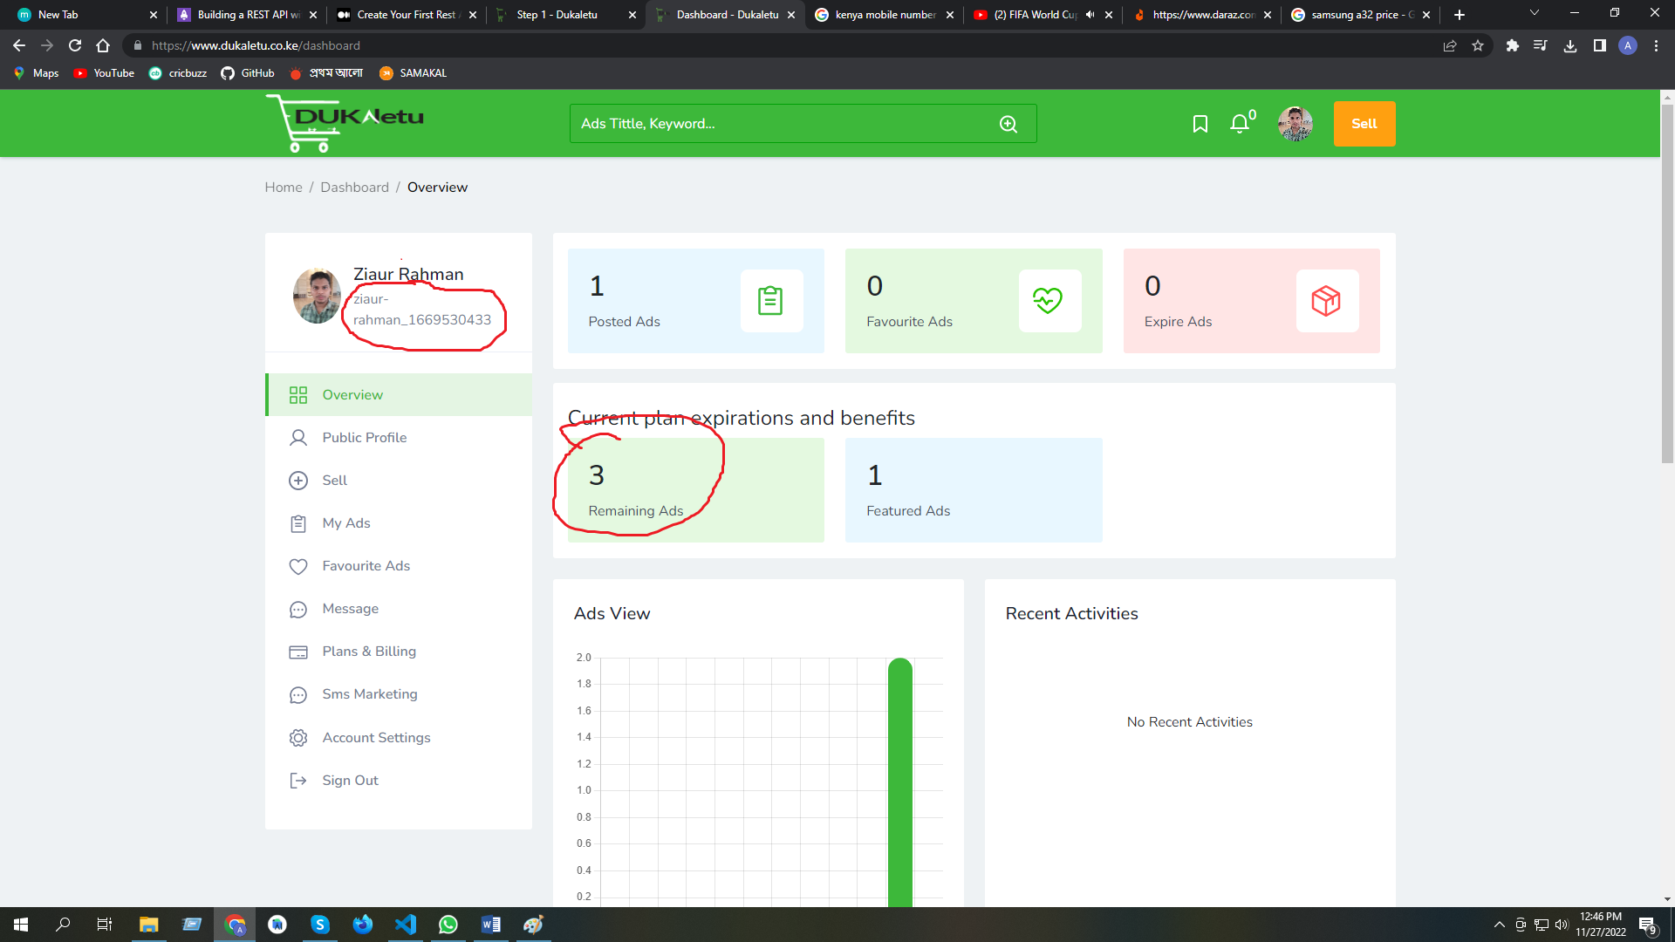

1. ads posting error